Login to the App Gateway: <https://apddirect.my.idaptive.app/>

Once logged in, you may have to “Reload Rights”. To do this, go to the top, far right of the screen. Locate your “User Name” icon. In the dropdown next to your “User Name”, click on the “Reload Rights” command.

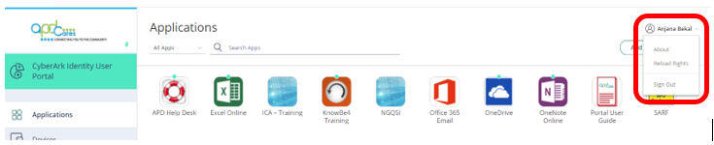



Once this is completed, you should see the new icon as shown below.

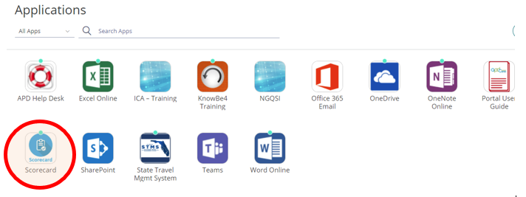

If you find the icon (circled in red), click it. Upon clicking this icon, you will be taken to the website shown below.



Prior to conducting an annual Support Plan Meeting, click on the “Create” button (shown above) to generate a unique Survey Invitation Code to provide to the selected client.

NOTE: The Survey Code is valid for 90 days.



Use the “Print this page” button (shown above) to print the invitation provide to the client or legal representative during the Support Plan Meeting.